BASEBALL / SOFTBALL PARKING

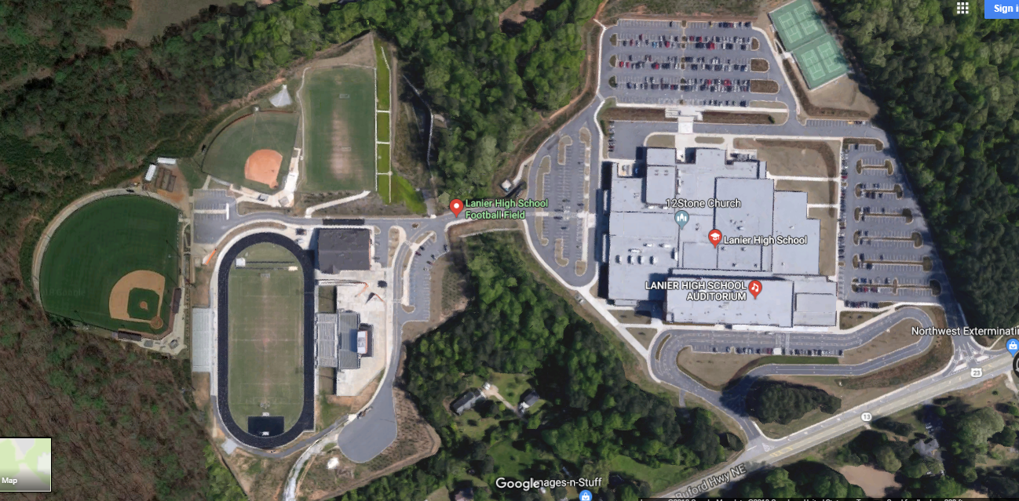

**Visitor**

**Parking**

Buses / Patrons Enter Here

*Go Past “Do Not Enter”

**Baseball Field**

**Softball Field**

**Bus**

**Parking**